SOLUTION ARCHITECTURE

A Novel Method for Handwritten Digit Recognition System

***Team Members: Premkumar, Sathya Varshini RD, Susmeta A, Vishnu Dharshan, Yashwanth.***

# PROJECT DESCRIPTION:

Handwriting detection is one of the most fascinating scientific projects currently under progress because everyone has a unique writing style. Everything is becoming digitalized to minimize human effort as a result of scientific and technological advancements. In many real-time applications, handwritten digit identification is therefore necessary. Artificial neural networks can assist computers in automating the process of finding and identifying images of numbers. The user can upload an image of a handwritten digit using a web application that has been created.

# TECHNICAL ARCHITECTURE:

Block Diagram of the model proposed:

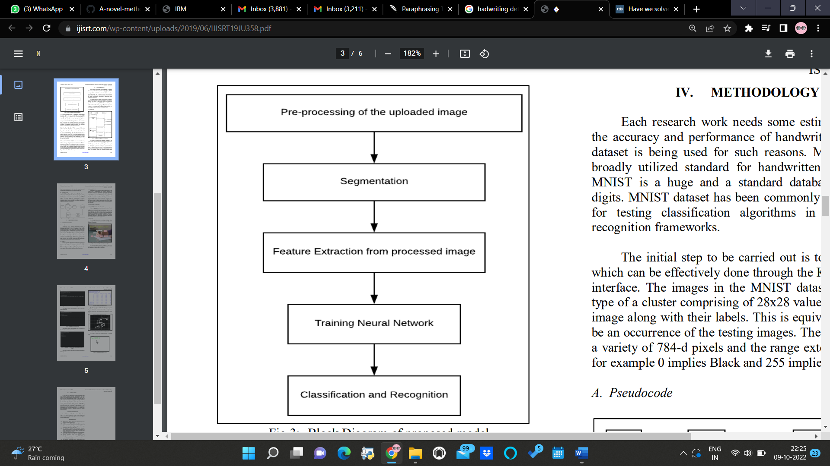

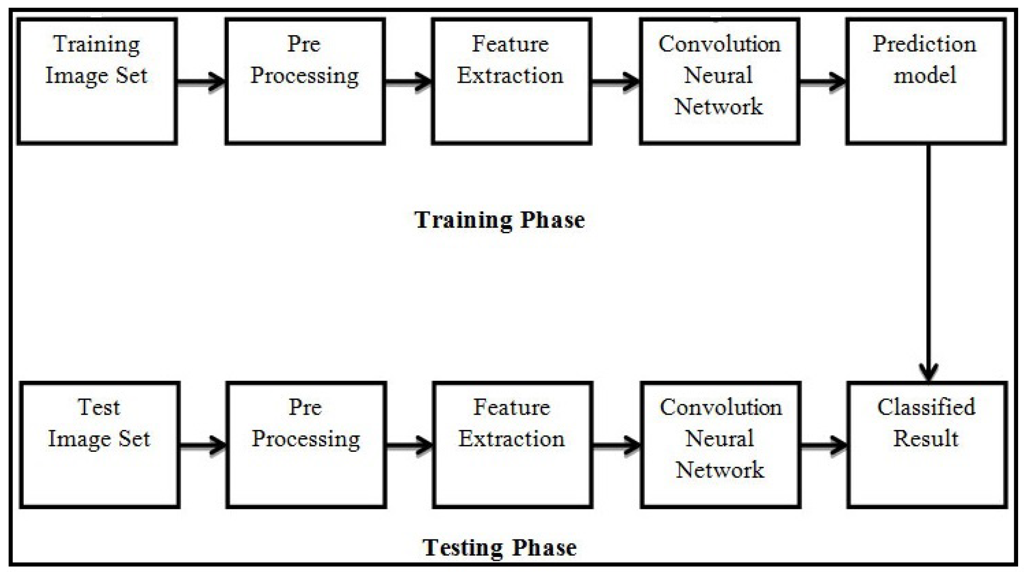

**SOLUTION:**

# MNIST Dataset :

There are 60,000 training and 10,000 testing handwritten digit images in the MNIST Handwritten Digit Recognition Dataset. The total number of pixels in each image is 784 (2828), with 28 pixels each for height and breadth. A single pixel value links every pixel together. It displays the pixel's brightness or darkness (larger numbers indicates darker pixel). An integer between 0 and 255 represents the value of this pixel.

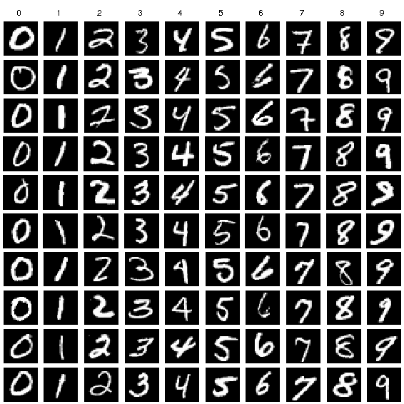

# PROCEDURE:

1. Set up the most recent TensorFlow library.
2. The MNIST dataset should be prepared for the model.
3. For the purpose of classifying the handwritten digits, create a single layer perceptron model and plot the change in accuracy per epochs.
4. Evaluate the model on the testing data.
5. Analyze the model summary.
6. The model can be made into a multi-layer perceptron by adding a hidden layer.
7. To avoid overfitting and assess its impact on accuracy, include Dropout.
8. Increasing the number of Hidden Layer neuron and check its effect on accuracy.
9. Use different optimizers and check its effect on accuracy.
10. Check the accuracy impact of increasing the hidden layers.
11. Change the batch size and epochs, then assess the impact on accuracy.

**Approach**:

A dataset that is frequently used for handwritten digit recognition is MNIST with  10,000 test photos and 60,000 training images. Artificial neural networks, the crucial component in the field of image processing, can most closely resemble the human brain. Using the MNIST dataset, handwritten digit recognition is a significant effort that was created with the use of neural networks. In essence, it recognizes the scanned copies of handwritten numbers. Three-layered Neural Network could be deployed.

* **The input layer**: It distributes the features of our examples to the next layer for calculation of activations of the next layer.
* **The hidden layer**: They are made of hidden units called activations providing nonlinear ties for the network. A number of hidden layers can vary according to our requirements.
* **The output layer**: The nodes here are called output units. It provides us with the final prediction of the Neural Network on the basis of which final predictions can be made.

A neural network is a model of the way the brain operates. Its several layers and numerous activations mimic the neurons in our brain. A neural network tries to infer a set of parameters from a set of data, which could help it identify underlying connections. Neural networks can offer the greatest outcomes without having to reevaluate the output criteria since they can adapt to changing input.

# METHODOLOGY:

One hidden layer and 100 activation units were used to form a neural network (excluding bias units). Data from a.mat file is loaded, after which features (X) and labels (Y) are extracted. Features are then divided by 255 and rescaled into a range of [0,1] in order to prevent calculation overflow. 10,000 samples are used for testing, and 60,000 examples are used for training. The training set is used using feedforward to derive the hypothesis, and then backpropagation is used to minimise error between the layers. The regularisation parameter lambda is changed to 0.1 in order to address the overfitting problem. For the best fit model, the optimizer is run 70 times.

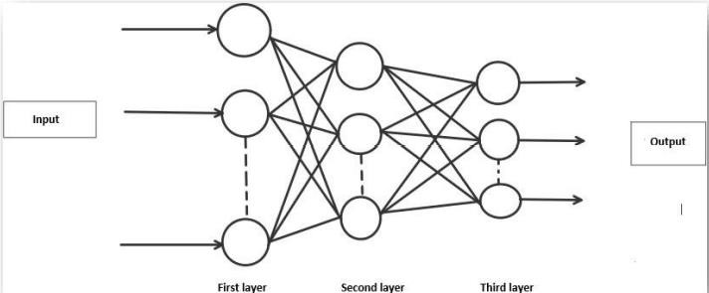

# ALGORITHM:

**Forward Propagation Architecture:**

## This is a succinct explanation of how the CNN module will extract features and classify the image using them. The network design shows the input layer, hidden layers, and output layer. The network's feature extraction phase includes a number of layers, including convolution and resampling.

## The User layer is the top layer of the architecture. The users who engage with the programme and get the desired outcomes make up the user layer.

The application's frontend architecture is made up of the following three levels. The open-source platform for HTML, CSS, and JavaScript will be used to construct the application. The application is installed on the localhost, which the browser displays. The user can upload images of the handwritten numbers to the app to have them transformed into digital form.

The business layer, which performs logical calculations in response to client-side requests, is the layer that lies between the database and view layers. Furthermore, it has the service interface.

Two datasets—Training Data and Test Data—make up the backend layer. A training set of 60,000 examples and a test set of 10,000 examples have already been created in the MNIST database. Convolution neural network is the training algorithm employed. In order to categorise the digits in the test data, the trained model must first be prepared. As a result, we can categorise the digits in the photos as Class 0,1,2,3,4,5,6,7,8,9.

# WORKING:

Neural networks take in data and process it through a number of secret layers. Each hidden layer is composed of a group of neurons, each of which is fully linked to every neuron in the layer above. Each layer of neurons has perfect independence. "Output layer" refers to the final layer that is entirely connected.

## TensorFlow:

An open-source machine learning library for research and development is called TensorFlow. For developers of all skill levels, TensorFlow provides APIs for desktop, mobile, web, and cloud platforms. To begin, look at the sections below. Text and sound output can be obtained by scanning the number digit and converting it to png format using the python3 command at the terminal.

## Feature Extraction:

A feature's neurons all have the same weights. This method allows all neurons to recognise the same feature in the input image at various locations. fewer free parameters should be used.

## Pooling layer:

In a Convent architecture, a Pooling layer is frequently inserted in between succeeding Conv layers. Its purpose is to gradually shrink the spatial size of the representation in order to decrease the amount of parameters and computation in the network and hence control overfitting. The Pooling Layer applies the MAX operation individually to each depth slice of the input and resizes it spatially.

## Convolution Layer:

## The foundational component of a CNN is the convolutional layer. The layer's parameters are made up of a number of learnable filters (or kernels), each of which has a limited receptive field but covers the entire depth of the input volume. Each filter is convolved across the width and height of the input volume during the forward pass, computing the dot product between the entries of the filter and the input and creating a two-dimensional activation map of that filter. As a result, the network picks up filters that turn on when a particular kind of feature appears at a certain spatial location in the input.

## Subsampling Layer:

Reducing a signal's total size is referred to as subsampling or down sampling. The spatial resolution of each feature map is decreased by the subsampling layers. Shift or distortion invariance is obtained by reducing the impact of sounds.

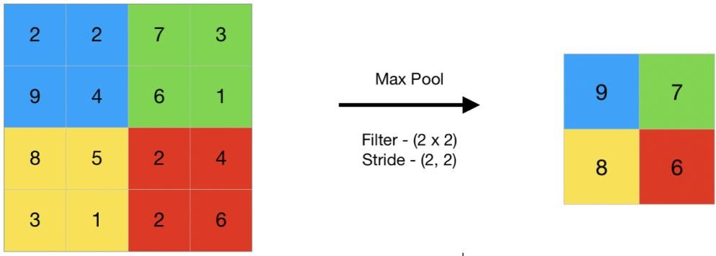

# RESULT:

Despite processing, we do not believe that our outcomes are flawless. There is always opportunity for improvement in your procedure because machine learning is a topic that is constantly developing. Additionally, there will always be new approaches that offer better results for the same problems. It has been done, the application. Convolution neural network (CNN), multi-layer perceptron (MLP), and network (CNN). Depending on which model is more accurate, the classifier's accuracy varies.